**ADAudit.ps1 Prerequisites and Instructions**

The script should be executed from an elevated PowerShell terminal on a domain-joined Windows host with the following software installed:

1. .NET Framework 3.0 or later (Windows 7 includes 3.0)

2. PowerShell 2.0 or later (Windows 7 includes 2.0)

3. Remote Server Administration Tools (RSAT):

Standalone RSAT Installer: Windows 10 (<https://www.microsoft.com/en-au/download/details.aspx?id=45520>)

Executing The Script  
(Executing the script using "Domain Admin" credentials is not required but is preferred because it provides additional output)

**Execution Syntax**  
PS C:\>.\ADAudit.ps1 -DomainController <IP or FQDN> -Credential <domain\username> -OutputType All

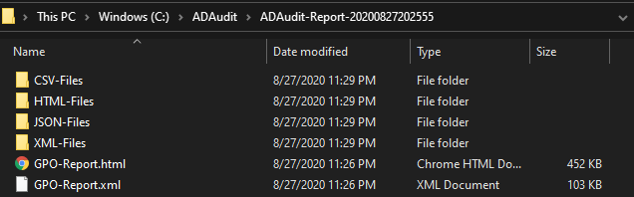

*The -OutputType flag used above is not required but provides additional formats if necessary. By default, the script will output CSV-Files and both GPO-Report file types when -OutputType is not defined.

## Generating The Report

If the script is executed from a domain-joined Windows host with Microsoft Excel installed, an XLSX report will automatically be generated. Otherwise, the script will output several CSV files that can be used to generate the report from a computer where Excel is installed.

To generate the ADAudit-Report.xlsx based on ADAudit.ps1 output (CSV-Files shown above)

**Report Generation Syntax:**  
PS C:\>.\ADAudit.ps1 -GenExcel C:\ADAudit-Report-<timestamp>

